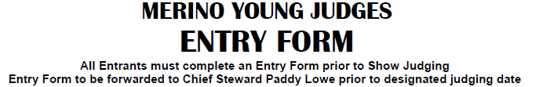

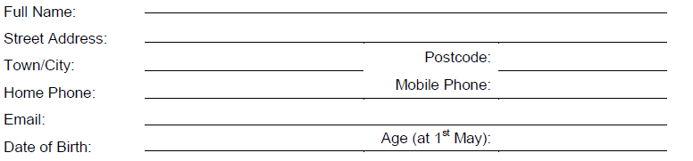

Entrants Declaration:
I have read and understood the Young Judges rules as outlined in AgShows NSW Merino Junior Judging Operational guidelines and agree to be bound in all aspects to these rules.
By signing below, I confirm that I agree to participate at my own risk and will follow the safety rules and instructions provided by event organisers. I understand that event organisers are not liable for any injuries sustained during the challenge.
If under 18 years please complete the following:
Parent/Guardian name: ____________________________ Mobile/phone: _______________________
Parent/Guardian email address: __________________________________________________________

